Certificate of Completion

Michael Surdek

Southern New Hampshire University

IT 697: Python Experiential Learning Activity

Dr. Bhanu Kapoor

July 18, 2021

**TABLE OF CONTENTS**

Experience Example…………………………………………………………….……….….….…2

Record of Hours in Experience……………………………………………………………………3

Future Application of Skill………………………………………………………………….….…4

Appendix A: Timesheets….….……………………………………………………………………5

**EXPERIENCE EXAMPLE**

One artifact that I produced as a result of this experiential learning activity in Python is a chart based on PGA Tour statistics for individual players’ seasons from 2010 to 2018. As I wrote in my reflection journals towards the end of the experience, I spent the first four weeks becoming acquainted with python basics, the next three weeks exploring some more intermediary topics such as data wrangling and visualization, and the final three weeks wrapping up the experience which included trying my hand at a data visualization project. I knew that I needed to create a piece of work that demonstrates how my knowledge and abilities in python have grown over the last ten weeks. This particular image is a result of everything that I have learned about python, including but not limited to working in an execution environment, importing and cleaning data, and using matplotlib as a visualization tool.

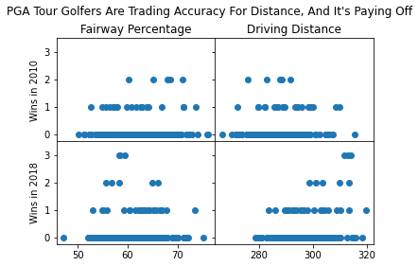

**RECORD OF HOURS IN EXPERIENCE**

Over the ten weeks of this experiential learning activity, I engaged in 81 total hours of research, learning, and self-practice. A lot of this time was spent reading and working through three books as my main resources. The books were our online textbook, Introduction to Scripting, and two other books that I purchased, Python for Data Analysis and Learn Python the Hard Way. Many other hours were spent engaged in the weekly discussions, script assignments, and final projects. The end of each week usually consisted of between an hour and an hour and a half compiling my reflection journals.

Through the first five weeks, I had spent 42.5 hours on this experience, which was somewhat ahead of the recommended pace of eight hours per week. In the second half of the course, I routinely spent seven or eight hours per week engaged in this experience, which was okay as I was in a good position to exceed the 80 hours required for the experience. In my SQL experiential learning activity, when I was also enrolled in a second course, I would have to work all day each Sunday. This time around, it was easier to accumulate hours early in the week, and I was more frequently able to finish my weekly activities at a time that was not my last possible chance before midnight on Sunday.

**FUTURE APPLICATION OF SKILL**

I believe that the skills and competencies I have acquired as part of this experience will benefit me in future Data Analytics courses and professional opportunities. After my first experiential learning activity, I discovered that I will be best off if I spent the time to get ahead of the recommended pace in order to improve the quality of my reflections, overall learning, and projects later on. I also hope that what I have learned through this experience will continue to benefit me in future job opportunities. This experience has not only provided me with python skills that will improve my technical abilities, but it has also shown me how to effectively solve problems, maintain a drive for learning, explore new tools and technologies, and communicate well with others. In my week five reflection journal, I quoted our Introduction to Scripting textbook and discussed how the quote changed my perspective on the role that data plays in a business environment. The textbook said “data are items that pertain to some event, activity, or experiment that we are interested in knowing more about.” (Miller, 4.2) My experience of learning python over the last ten weeks was more than discovering how to write code. It was also an opportunity to understand how data can be used to generate insights that solve problems and make things easier for business users in certain situations. I believe that an understanding of python is an essential requirement of the positions that I hope to compete for in the future, whether they will be on the business or technical side of things.

**APPENDIX A: TIMESHEETS**

Week 1

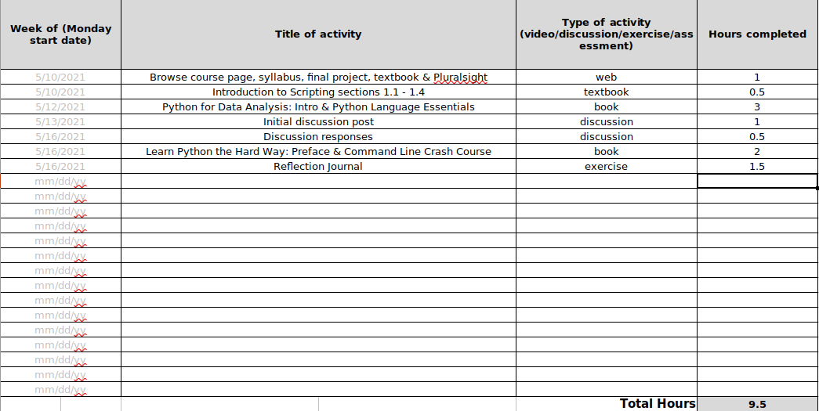Week 2

Week 3

Week 4

Week 5

Week 6

Week 7

Week 8

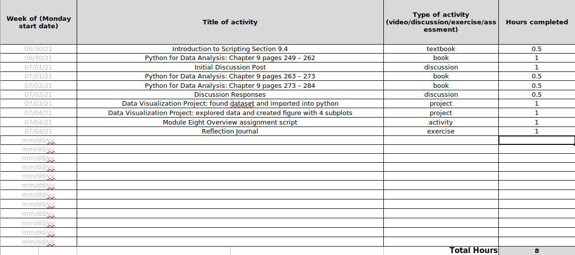

Week 9

Week 10

References

McKinney, William-Wes. 2012. Python for Data Analysis. *O’Reilly*.

Miller, Bradley and Ranum, David. 2017. Introduction to Scripting. *Jones & Bartlett Learning.*

Shaw, Zed A. 2014. Learn Python the Hard Way. *Addison-Wesley*.